Dimitri Vastenhout - 4983750

29/5/2022

Assignment 6

Container rental – A company rents out containers and a program that calculates the income, volume and longest rental period must be made.

Lecturer: Rob Loves

Problem Definition

A container company rents containers there is 40 € rent per day per m3 at the end of the period the containers need to be taken away which cost 60 € if the volume of the container is less than or equal to 2 m3, else it will cost 125 €.

The user must only have to input for each container:

* The volume in form of a positive double
* The start date as a string and written in the form of ddmmyyyy
* The end date as a string in the form of ddmmyyyy

For how many containers they want to rent. The program will have to output:

* The total cost of the containers for the rented period
* The total income of all the rented containers
* The average volume of containers rented
* The longest rental period

GUI

-Insert Container Page

-View Rental Page

-Statistics Page

-About Page

Input and Output

Input

|  |  |
| --- | --- |
| Case | Type |
| volume | integer |
| startDate | ddmmyyyy - string |
| endDate | ddmmyyyy - string |

Output

|  |  |
| --- | --- |
| Case | Type |
| Cost of container for rental period | integer |
| Total income of all rented containers | integer |
| Average volume of rented containers | double |
| The longest rental period | ddmmyyyy - string |

Remarks

* Input will be checked
* Negatives will be automatically turned to positives
* Incorrect dates will be converted to closest values in terms of numbers

Class diagram

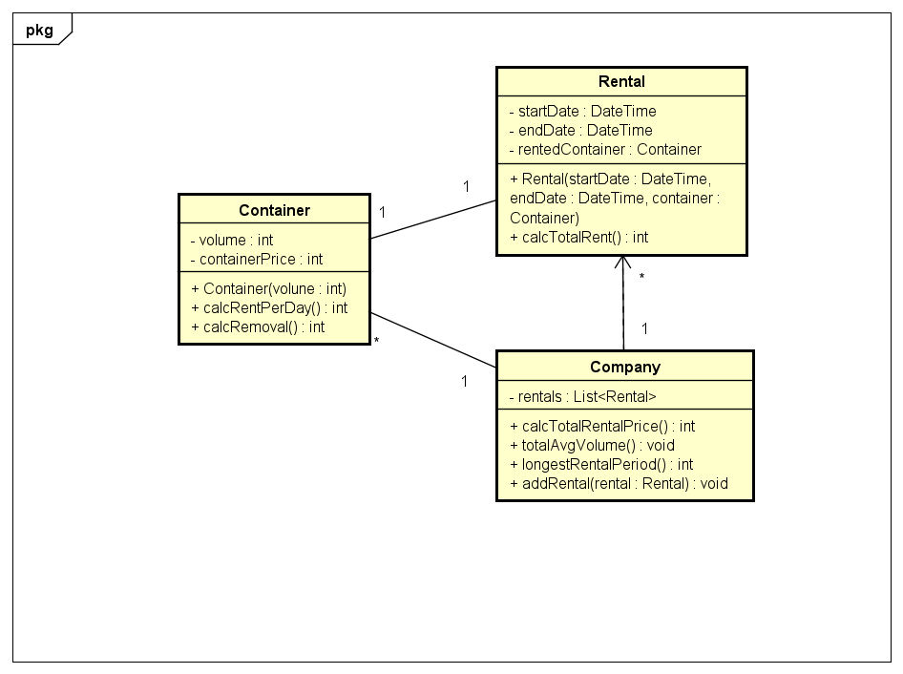

Test Plan

Test Data

|  |  |  |  |  |  |
| --- | --- | --- | --- | --- | --- |
| Input | | | Output | | |
| Container | Start | End | Total Costs | Total Income | Longest Period AVG |
| 15 | 12132022 | 25122022 | 7925 | 7925 | 13 |
| 20 | 06062022 | 30062022 | 19325 | 27250 | 18.5 |
| 70 | 18072021 | 20082021 | 92525 | 119775 | 23.33 |
| -63 | 19102022 | 32122022 | 184085 | 303860 | 35.75 |